Steps：

1. gcc paging.c
2. ./a.out 19986

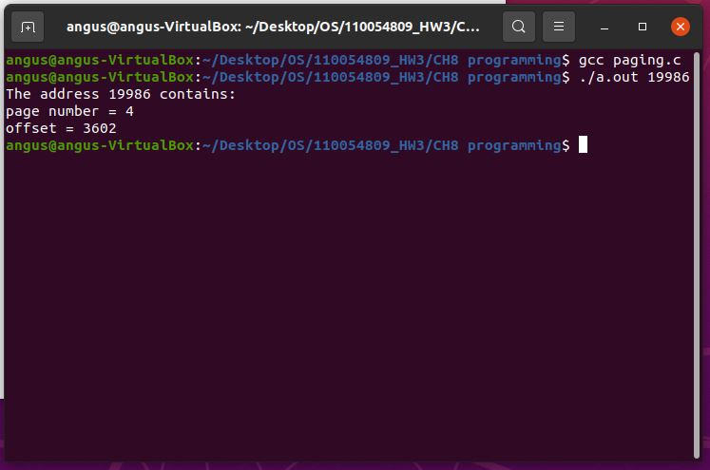

Source code：

#include<stdio.h>

#include<stdlib.h>

#define pageSize 4096

int main(int argc, char \*argv[]) {

unsigned long page, offset, address;

address = atoi(argv[1]);

page = address / pageSize;

offset = address % pageSize;

printf("The address 19986 contains:\n");

printf("page number = %lu\n", page);

printf("offset = %lu\n", offset);

return 0;

}